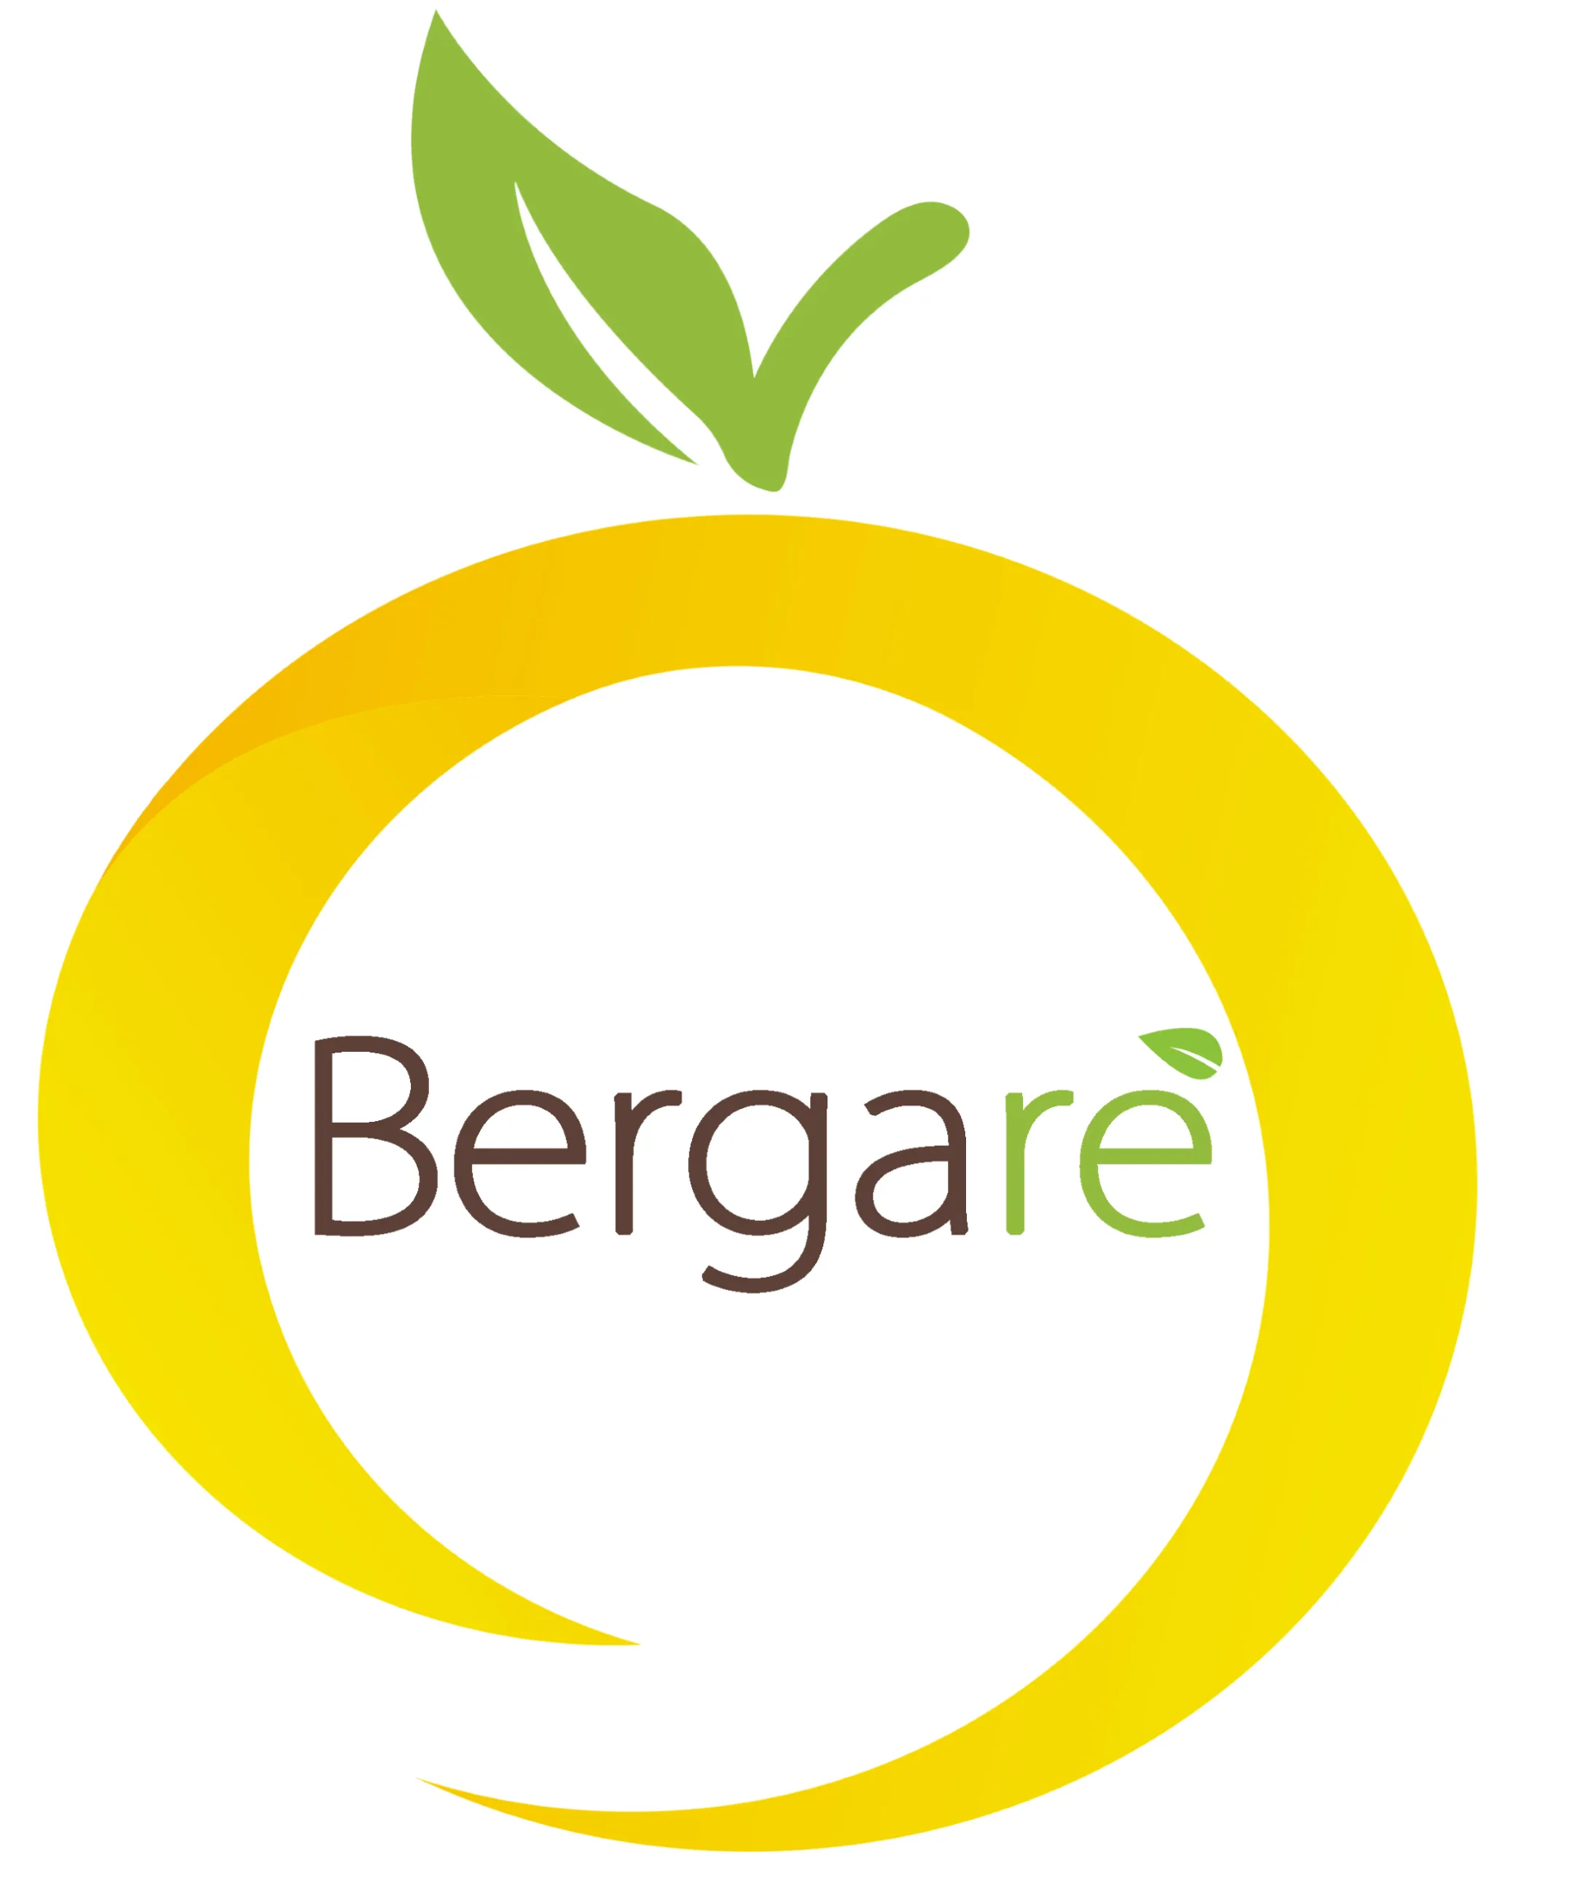
BERGARÈ 2026
B2B INCOMING MISSION – REGGIO CALABRIA
22–24 October 2026
BUYER APPLICATION FORM
Please return the completed form to business@ccitabel.com by 28 August 2026
Please complete all sections of this form. Selected buyers will receive further information regarding travel arrangements, accommodation and the scheduling of B2B meetings.
1. COMPANY AND CONTACT DETAILS

COMPANY NAME
COMPANY WEBSITE
REGISTERED ADDRESS
CITY / COUNTRY
VAT / COMPANY REGISTRATION NO.
CONTACT PERSON – FIRST NAME
CONTACT PERSON – SURNAME
JOB TITLE / POSITION
EMAIL
PHONE NUMBER

2. COMPANY PROFILE

☐ Importer | ☐ Distributor / Wholesaler
☐ Retailer – single specialised store | ☐ Retailer – chain / multiple points of sale
☐ Ho.Re.Ca. operator | ☐ Restaurant / restaurant group
☐ E-commerce platform | ☐ Large-scale retail / supermarket chain
☐ Food service / catering | ☐ Other (please specify): __________________________________________

BRIEF DESCRIPTION OF YOUR COMPANY:
ANNUAL PURCHAISING VOLUME:

3. PRODUCT INTERESTS

☐ Bergamot-based products | ☐ Extra virgin olive oil
☐ Preserves, sauces and spreads | ☐ Fruit juices and beverages
☐ Confectionery and bakery products | ☐ Artisanal pasta
☐ Cheese and dairy products | ☐ Cured meats, nduja and savoury specialities
☐ Organic products | ☐ Other products: __________________________________________

DO YOU CURRENTLY IMPORT ITALIAN PRODUCTS? | ☐ Yes ☐ No
ARE YOU FAMILIAR WITH THE TYPICAL FOOD PRODUCTS OF CALABRIA REGION? | ☐ Yes ☐ No

4. DECLARATION

I confirm that the information provided in this application is accurate and complete. I understand that submitting this form does not automatically guarantee participation and that the final selection will be made by the organizers based on the applicant’s professional profile and business relevance.
By joining the initiative and submitting the completed registration form, participants formally commit to attending if selected by the organizers. In the event of cancellation, a penalty fee may apply, and they may be excluded from participation in future events.
By registering for this event, you agree that information that you or those acting on your behalf may provide to us are integrated into the Belgian-Italian Chamber of Commerce's file management database. The data that we hold will not be shared with any third parties for marketing purposes. They will be used for the sole purpose of sending other information about our institution and related activities. You can always easily unsubscribe by writing to info@ccitabel.com
PLACE AND DATE
NAME AND SURNAME
SIGNATURE

